Editors, PS

Dear Editors,

I would like to introduce you to this new short research note composed by my co-author Bernard Grofman (Professor, University of California Irvine) and myself. We are calling this article **“Why Donald Trump Should be a Fervent Advocate of Using Rank-Choice Voting in 2024”**. This article builds off work by Devine and Kopko (2021) and Lacy and Burden (1999) who estimate a probit model of candidate choice from the CCES to determine the second choice of third-party voters. Using this model on 2020 election data, we show that the Libertarian candidate Jo Jorgenson probably cost Donald Trump victory in at least two state – AZ and GA. Additionally, the popular vote margin enjoyed by Joe Biden could have been between 260,000 and 525,000 votes less, using conservative estimates.

The motivation of this paper is to give contrary evidence for two main misconceptions. First, that third-party candidates are “spoiling” elections for the Democrats. Our evidence clearly shows that third-parties have the potential to hurt either of the two main parties, but in 2020, it was Donald Trump who was hurt most; though not consequentially. Second, some reformers believe that Rank Choice Voting benefits the Democrats; again, we show that, *all else being equal*, it is the Republicans that would have benefited by the change in rules, since the majority of third-party votes are going to the Libertarian candidate, and whose voters prefer Republicans over Democrats 60% to 32%.

While this contribution is minor, we believe it is non-the-less important and that PS readers would find the research compelling and of interest.

Sincerely,

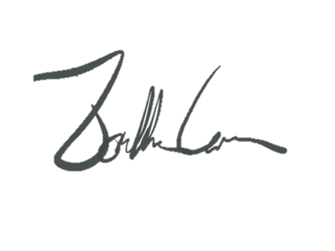

Jonathan Cervas